SCAVENGER HUNT FOR BENEFICIAL BUGS

Material:
- Digital Camera (cell phone cameras work well too)
- Beneficial bug tally guide (printable handouts below)
- Access to the website http://beneficialbugs.org/index.htm

Because there are so many stinging and biting insects, we forget that there are insects that help us. These are “Beneficial insects” that pollinate flowers and keep pest insects (like mosquitoes) at low numbers. You can find beneficial insects all during warm weather in North America.

Beneficial insects live in many places where you can find them during the spring, summer, and fall. If you do find a beneficial bug – don’t touch it. Take a picture of it with your cell phone camera. Then share the picture with your teacher and classmates. You should look for beneficial insects in:
- gardens,
- backyards,
- inside dead logs and under dead wood
- under piles of leaves – particularly dried leaves
- in compost heaps
- in flower patches
- around flowering tree and bushes
- in your school garden
- around lights at night
- in the cracks of sidewalks
- in a public garden or arboretum
You can use a “field guide to insects” or the website http://beneficialbugs.org to identify insects in the pictures you have taken. Below, you will also find a hand-out that is designed with line drawings of most of the insects that you will find in North America. Keep a computer file of the insect pictures you have taken.
To help you identify beneficial insects, you should take notes about where you found them and what they were doing. What did it look like? Do you think it was a predator or a pollinator? Was it camouflaged or brightly colored? Was it on a plant? Where? Was it eating anything? What else was it doing? With a little research, you can probably figure out what insects you found.
You and your classmates can study the beneficial insects in your area by keeping a Tally Sheet. There is an example of a tally sheet that you can print-out below.

NAME_____________________________
BENEFICIAL BUG HUNt – Tally Sheet
BUG HUNT TALLY
Find as many different kinds of beneficial insects and spiders listed below that you can. Place a tally mark beside each kind of creature each time you find one.
Beneficial Insect | Insect Drawing | Habitat and activity descriptions | Tally -How Many Did you Find?
PRAYING MANTID | 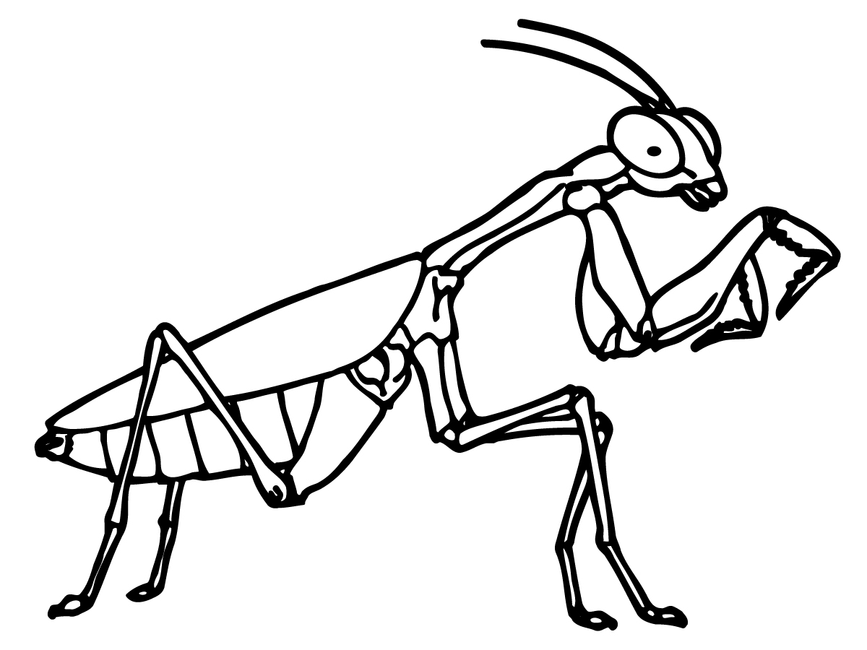
LADY BEETLE | 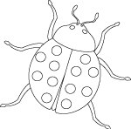
GREEN LACEWING | 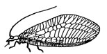
WASP | 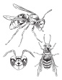
ASSASSIN BUG | 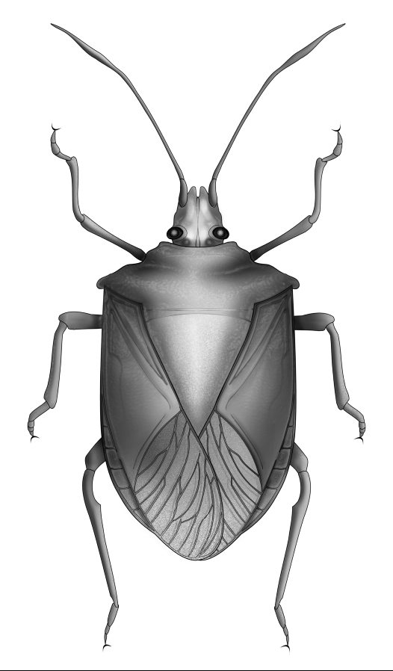
Honey BEE | 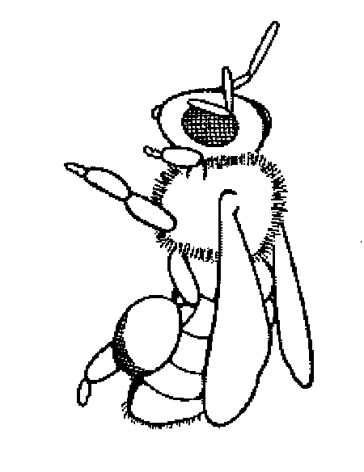
Firefly | 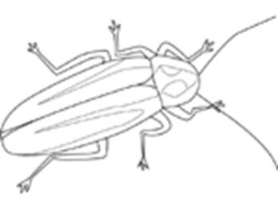
Dragonfly | 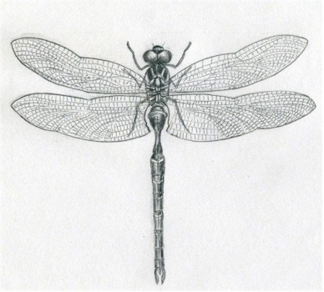
Tachnid fly | 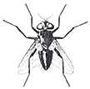
Pirate Bug | 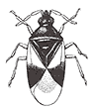
Predatory Mite | 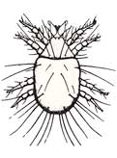
Syrphid Fly | 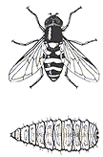
Millipede | 
Stonefly | 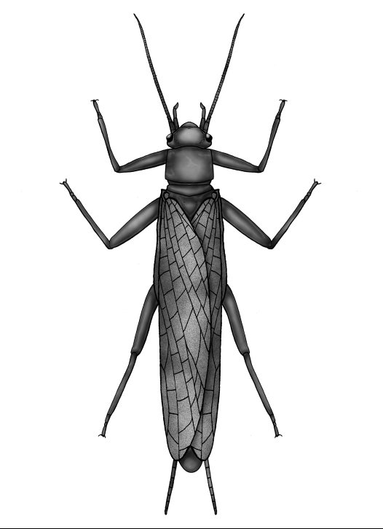
Agile Ground Mantid | 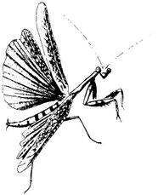
Sowbug | 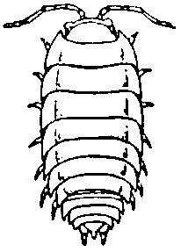
Big-Eyed Bug | 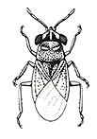

Created by Dr. Linda Mensing Triplett 2010

Standards addressed – National Science Standards – Science as Inquiry
http://www.nap.edu/openbook.php?record_id=4962&page=105

Science as Inquiry Standards
In the vision presented by the Standards, inquiry is a step beyond ''science as a process," in which students learn skills, such as observation, inference, and experimentation. The new vision includes the "processes of science" and requires that students combine processes and scientific knowledge as they use scientific reasoning and critical thinking to develop their understanding of science. Engaging students in inquiry helps students develop
- Understanding of scientific concepts.
- An appreciation of "how we know" what we know in science.
- Understanding of the nature of science.
- Skills necessary to become independent inquirers about the natural world.
- The dispositions to use the skills, abilities, and attitudes associated with science.
TABLE 6.1. SCIENCE AS INQUIRY STANDARDS
LEVELS K-4 | LEVELS 5-8 | LEVELS 9-12
Abilities necessary to do scientific inquiry | Abilities necessary to do scientific inquiry | Abilities necessary to do scientific inquiry
Understanding about scientific inquiry | Understanding about scientific inquiry | Understanding about scientific inquiry
Science as inquiry is basic to science education and a controlling principle in the ultimate organization and selection of students' activities. The standards on inquiry highlight the ability to conduct inquiry and develop understanding about scientific inquiry. Students at all grade levels and in every domain of science should have the opportunity to use scientific inquiry and develop the ability to think and act in ways associated with inquiry, including asking questions, planning and conducting investigations, using appropriate tools and techniques to gather data, thinking critically and logically about relationships between evidence and explanations, constructing and analyzing alternative explanations, and communicating scientific arguments. Table 6.1 shows the standards for inquiry. The science as inquiry standards are described in terms of activities resulting in student development of certain abilities and in terms of student understanding of inquiry

